MySQL JOINS are used with SELECT statement. It is used to retrieve data from multiple tables. It is performed whenever you need to fetch records from two or more tables.

There are three types of MySQL joins:

MySQL INNER JOIN (or sometimes called simple join)

MySQL LEFT OUTER JOIN (or sometimes called LEFT JOIN)

MySQL RIGHT OUTER JOIN (or sometimes called RIGHT JOIN)

Inner JOIN (Simple Join):

The MySQL INNER JOIN is used to return all rows from multiple tables where the join condition is satisfied. It is the most common type of join.
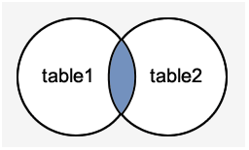

Example 1:

SELECT StudentName

FROM Student

INNER JOIN EnrolledCourse

ON Student.RollNo = EnrolledCourse.RollNo;

Left Outer Join:

The LEFT OUTER JOIN returns all rows from the left hand table specified in the ON condition and only those rows from the other table where the join condition is fulfilled.
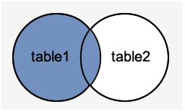

Example 2:

SELECT CourseName, CoursePrice, RollNo

FROM Course

LEFT JOIN EnrolledCourse

ON Course.CourseId = EnrolledCourse.CourseId;

Right Outer Join:
Right Outer Join returns all rows from the RIGHT-hand table specified in the ON condition and only those rows from the other table where he join condition is fulfilled.
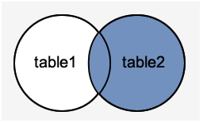

Example 3:

SELECT CourseName, CoursePrice, RollNo

FROM Course

RIGHT JOIN EnrolledCourse

ON Course.CourseId = EnrolledCourse.CourseId;

Implement Join using order by:

Example 4:

SELECT CourseName, CoursePrice, RollNo

FROM Course

Right JOIN EnrolledCourse

ON Course.CourseId = EnrolledCourse.CourseId ORDER BY EnrolledCourse.CourseId desc;

